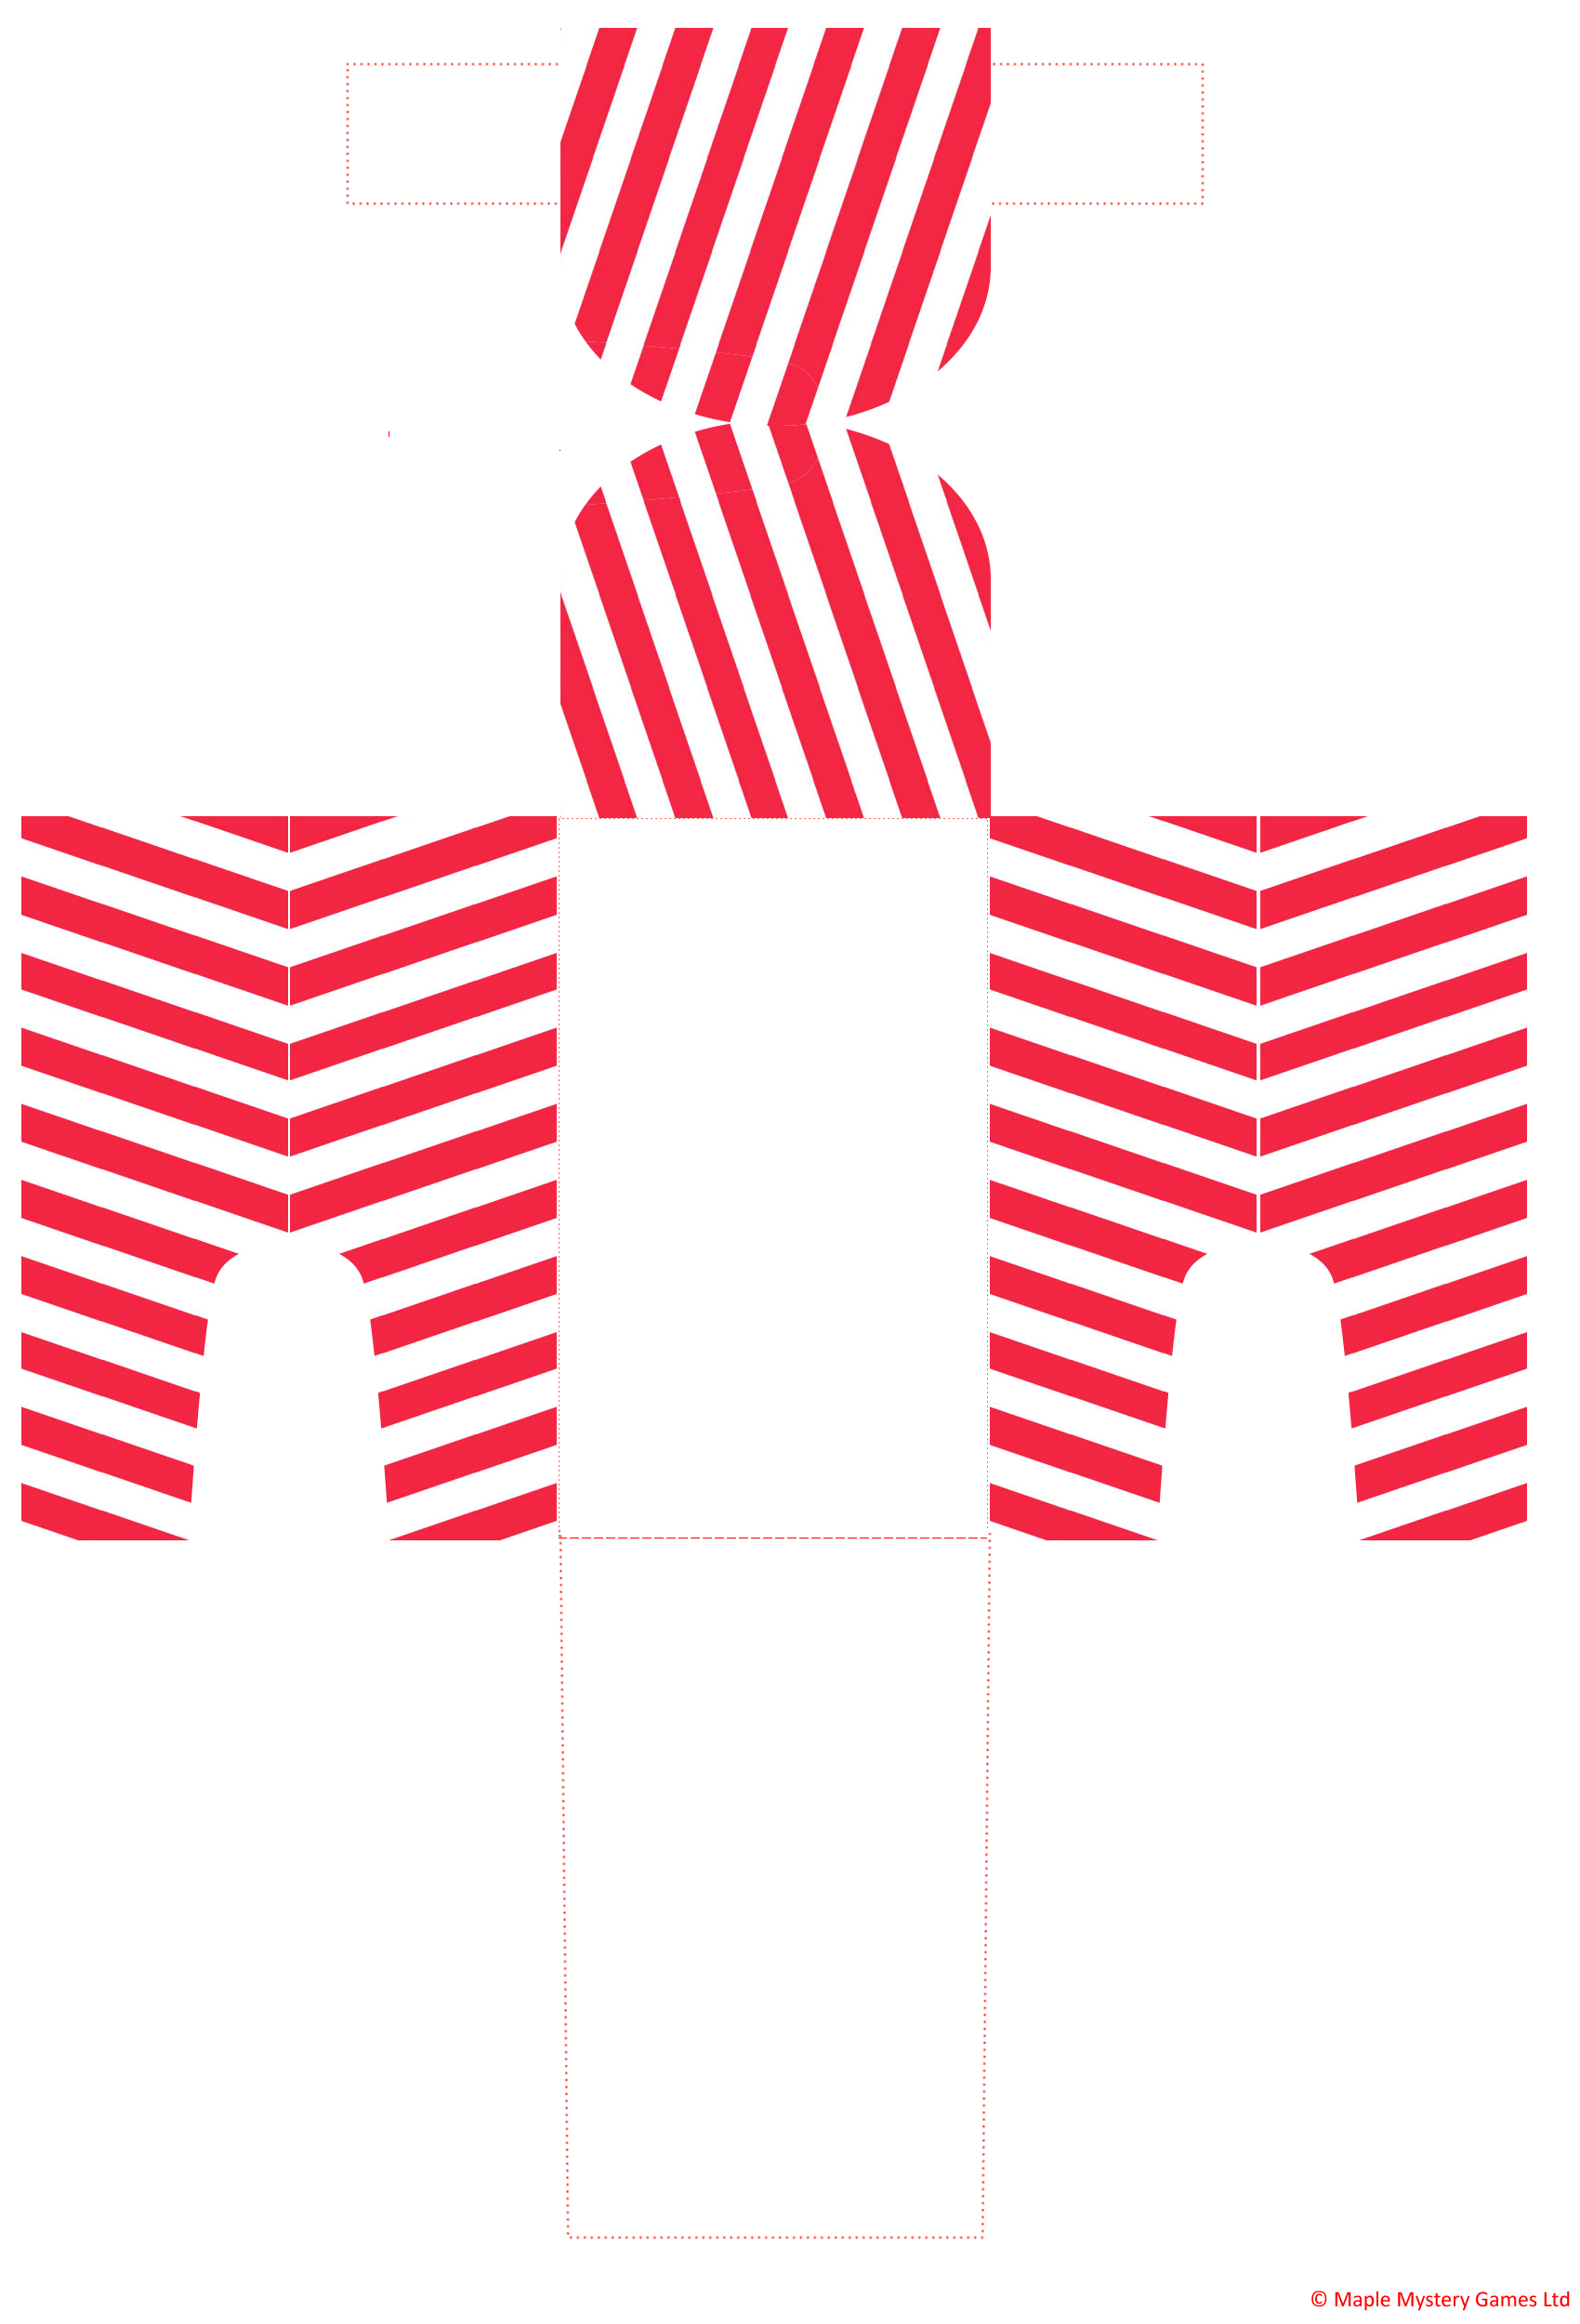

Add Name

Add Name

These sleigh place settings can be used as table place cards and also as a holder for chocolates, petit fours or small presents. They can be made using one sheet of paper per sleigh.

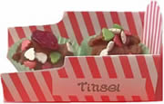

Optionally add candy canes as runners.

Detailed instructions for creating these sleighs are on: <https://maplemysterygames.com/christmas-murder-mystery-ideas/candy-cane-sleigh-place-cards/> (the page where this template was downloaded from).

The white boxes with “Add Name” are editable. You could resize if necessary. The font used is “Calibre” as this is on most PCs; feel free to use a Christmas font of your choice.

**Legal Use: Completed Sleigh Place Cards**

Completed sleigh place cards may be used freely for personal projects, personal decorations or personal parties.

If using commercially, or if using on a blog, attribution is required to <https://maplemysterygames.com/christmas-murder-mystery-ideas/candy-cane-sleigh-place-cards/>

Photos of completed sleighs can be given to websites or blog owners on request.

**Legal Use: Sleigh Place Card Template**

This sleigh place card template may not be redistributed (whether free or paid), or modified for redistribution. Nor may it be added to a bundle of other items for redistribution.

This sleigh place card template may not be placed online for others to use. Instead, please link to <https://maplemysterygames.com/christmas-murder-mystery-ideas/candy-cane-sleigh-place-cards/>